EE387 : **BASIC SIGNAL REPRESENTATION AND CONVOLUTION**

Premathilaka M.P.U

E/15/280

17/04/2020

PART 1: Basic Signal Representation in MATLAB

1. Write a MATLAB program and necessary functions to generate the following signal

y(t) = r(t+3) – 2r(t+1) +3r(t) – u(t-3)

Then plot it and verify analytically that the obtained figure is correct.

**Code for ramp function**

function y = ramp(t,m,ad)

% t: length of time

% m: slope of the ramp function

% ad: advance (positive), delay (negative) factor

y=[];

count=1;

p=-(ad/m);

for i=t

if(m>0)

if i< p

y(count)=0;

else

y(count)=m*i + ad;

end

else

if i< p

y(count)=m*i + ad;

else

y(count)=0;

end

end

count=count+1;

end

**Code for unit-step function**

function y = ustep(t,ad)

% ad: advance (positive), delay (negative) factor

% t: length of time

y=[];

count=1;

for i =t

if i< (-1*ad)

y(count)=0;

else

y(count)=1;

end

count=count+1;

end

Execute following programme,

clear all;

Ts=0.01;

t= -5:Ts:5;

y1 = ramp(t,1,3);

y2 = ramp(t,1,1);

y3 = ramp(t,1,0);

y4 = ustep(t,-3);

y = y1-2*y2+3*y3-y4;

plot(t,y,'k');

xlabel( 'time' ) ;

ylabel( 'y(t)' ) ;

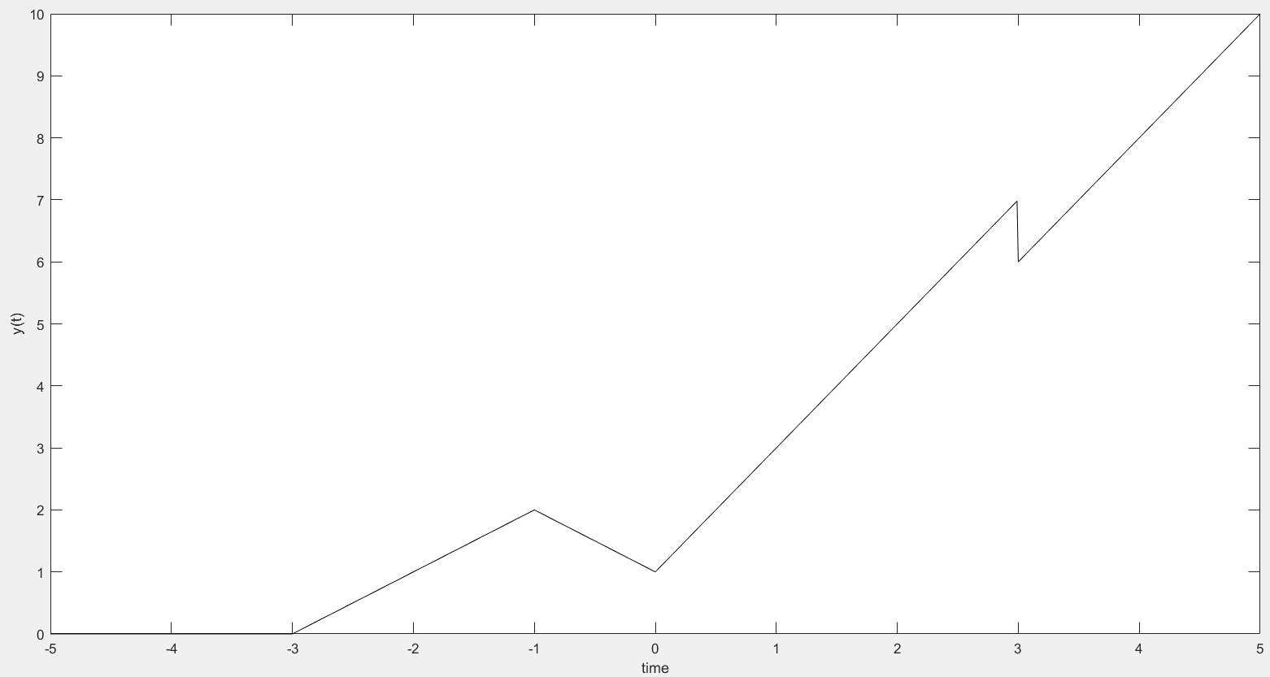

Figure 01: Variation of y(t) with time(t)

Analytical Explanation

The analysis of the graph can be divided into 5 regions in on the time axis.

**Region 1 (t < -3),**

In this region since there is no function involved, y = 0

Therefore, y(t) = 0

**Region 2 (-3 <= t < -1),**

The function y = t + 3 , involved in this region.

Therefore, y(t) = t + 3

As displayed on the graph, from -3 to -1 it has behaved according to y(t) = t + 3

**Region 3 (-1 <= t < 0),**

Two functions are involved in this region. They are y = (t+3) , y = (t+1)

Therefore, y(t) = (t + 3) – 2(t + 1) = (-t + 1)

As displayed on the graph, from -1 to 0 it has behaved according to y(t) = -t + 1 with negative gradient.

**Region 3 (0 <= t < 3),**

Three functions are involved in this region. They are y = (t+3) , y = (t+1), y = t

Therefore, y(t) = (t + 3) – 2(t + 1) + 3(t) = (2t + 1)

As displayed on the graph, from 0 to 3 it has behaved according to y(t) = 2t + 1 with positive increased gradient than in region 2.

**Region 4 (3 <= t),**

Four functions are involved in this region. They are y = (t+3) , y = (t+1), y = t , y = -1

(from the unit step)

Therefore, y(t) = (t + 3) – 2(t + 1) + 3(t) - 1 = (2t)

As displayed on the graph, above 3 it has behaved according to y(t) = 2t with the same gradient in region 1. Since the y intercept has decreased to 0, the graph has came down at t = 3.

1. For the damped sinusoidal signal x(t) = 3e-t cos(4πt) write a MATLAB program to generate x(t) and its envelope, then plot

**Code**

clear all;

Ts=0.01;

t= -5:Ts:5;

y=[];

count=1;

for i=t

y(count)=3*exp(-i)*cos(4*pi*i);

count=count+1;

end

[yupper,ylower] = envelope(y,30,'peak')

figure(1)

plot(t,y); hold on;

plot(t,yupper);

plot(t,ylower);

grid;

xlabel('t'); ylabel('x(t)')

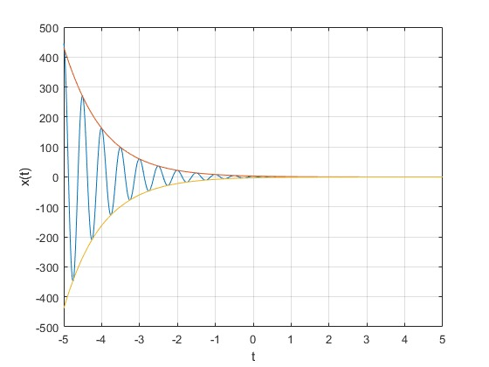

Figure 02: Variation of y(t) with time(t)

**PART 2: Time-Domain Convolution**

**Elementary signal operations**

**Code for rectangular pulse**

function x = rect(t)

x=[];

count=1;

for i = t

if (i> -0.5 & i<0.5)

x(count)=1;

else

x(count)=0;

end

count=count+1;

end

Execute following programme,

clear all;

f_s=100; % sampling frequency

T_s=1/f_s;

t =[-5:T_s:5];

x1 = rect(t);

x2 = rect(t-1);

x3 = rect(t/2);

x4 = rect(t)+(1/2)*rect(t-1);

x5 = rect(-t)+(1/2)*rect(-t-1);

x6 = rect(1-t)+(1/2)*rect(-t);

subplot(3,2,1);

plot(t,x1);

axis( [-2 2 -1 2]);

xlabel( 'time (sec)' )

ylabel('x_1(t)')

title ('Plot 1: A rectangular pulse');

subplot(3,2,2);

plot(t,x2);

axis( [-2 2 -1 2]);

xlabel( 'time (sec)' )

ylabel('x_2(t)')

title ('Plot 2: A time shifted pulse');

subplot(3,2,3);

plot(t,x3);

axis( [-2 2 -1 2]);

xlabel( 'time (sec)' )

ylabel('x_3(t)')

title ('Plot 3: A time scaled pulse');

subplot(3,2,4);

plot(t,x4);

axis( [-2 2 -1 2]);

xlabel( 'time (sec)' )

ylabel('x_4(t)')

title ('Plot 4: x4 = rect(t)+(1/2)*rect(t-1)');

subplot(3,2,5);

plot(t,x5);

axis( [-2 2 -1 2]);

xlabel( 'time (sec)' )

ylabel('x_5(t)')

title ('Plot 5: x5 = rect(-t)+(1/2)*rect(-t-1)');

subplot(3,2,6);

plot(t,x6);

axis( [-2 2 -1 2]);

xlabel( 'time (sec)' )

ylabel('x_6(t)')

title ('Plot 5: x6 = rect(1-t)+(1/2)*rect(-t)');

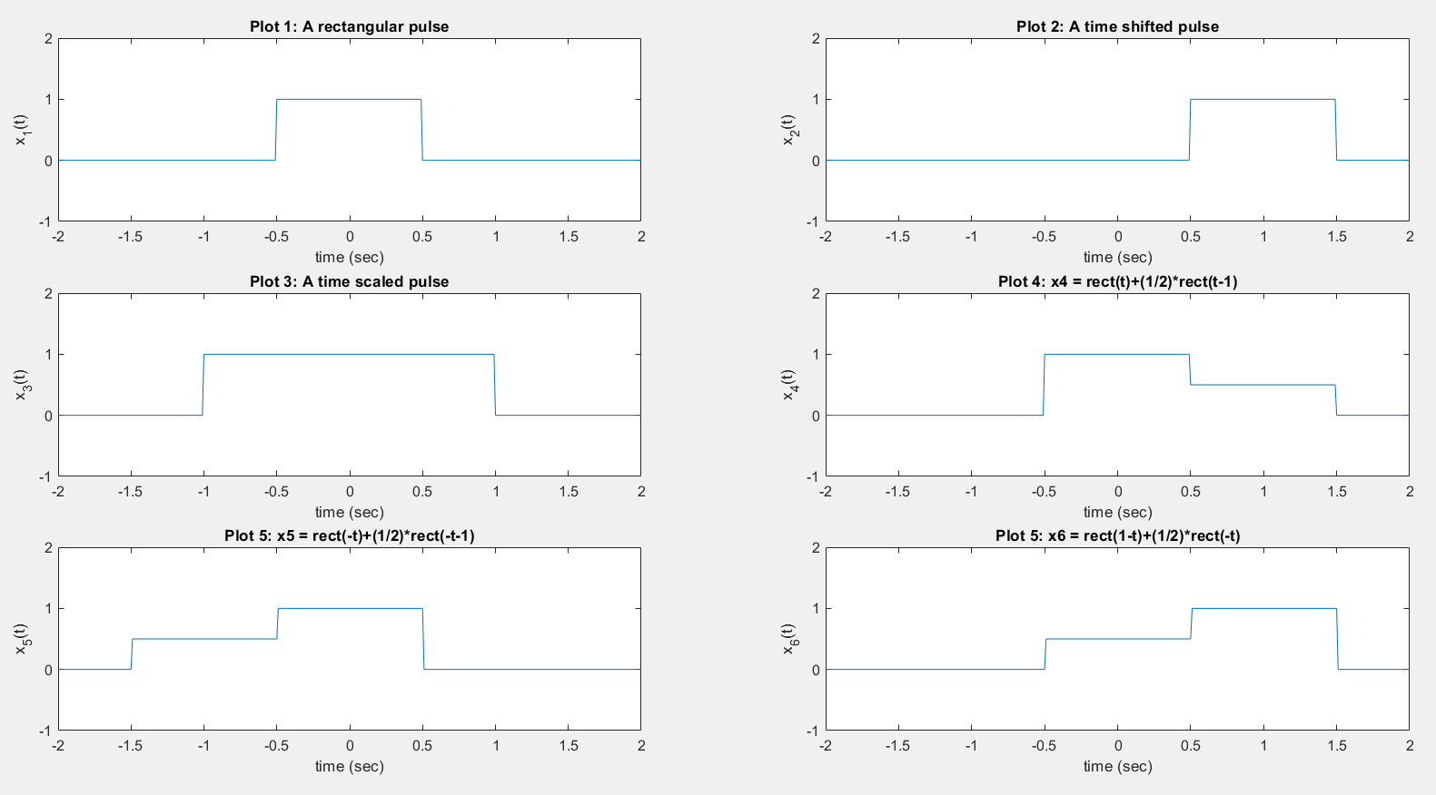

Figure 3: Variations of the function with time

**Convolution**

**Code for convolution**

clear all;

f_s=100; % sampling frequency

T_s=1/f_s;

t =[-5:T_s:5];

x1 = rect(t);

x2 = rect(t-1);

y = conv(x1,x1); %convolution of x1 and x2

t_y = -10:T_s:10; % seperate time axis for signal y

y1 = T_s*conv(x1,x1);

plot(t_y, y1);

axis( [-2 2 -1 2] ) ;

xlabel( 'time (sec)');

ylabel('y_1(t)');

title('Figure : y_1(t) = x_1(t)*x_2(t)');

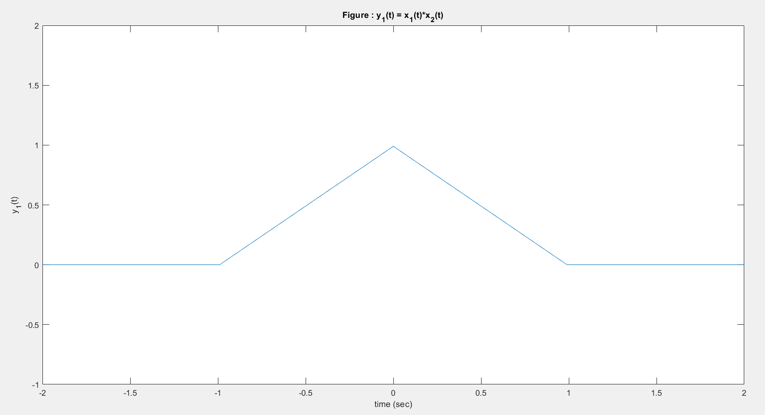

Figure 04: Variation of y_1(t) with time(t)

**EXERCISE**

1. 1) x(n) = { 1,2,4 }, h(n) = {1,1,1,1,1}

**Code**

clear all;

x=[1,2,3];

h=[1,1,1,1,1];

y=conv(x,h);

n1=1:length(x);

n2=1:length(h);

n3=1:length(y);

subplot(2,2,1);

stem(n1,x)

axis( [0 8 0 7]);

xlabel( 'n');

ylabel('x(n)');

subplot(2,2,2);

stem(n2,h)

axis( [0 8 0 7]);

xlabel( 'n');

ylabel('h(n)');

subplot(2,2,3);

stem(n3,y)

axis( [0 8 0 7]);

xlabel( 'n');

ylabel('y(n)');

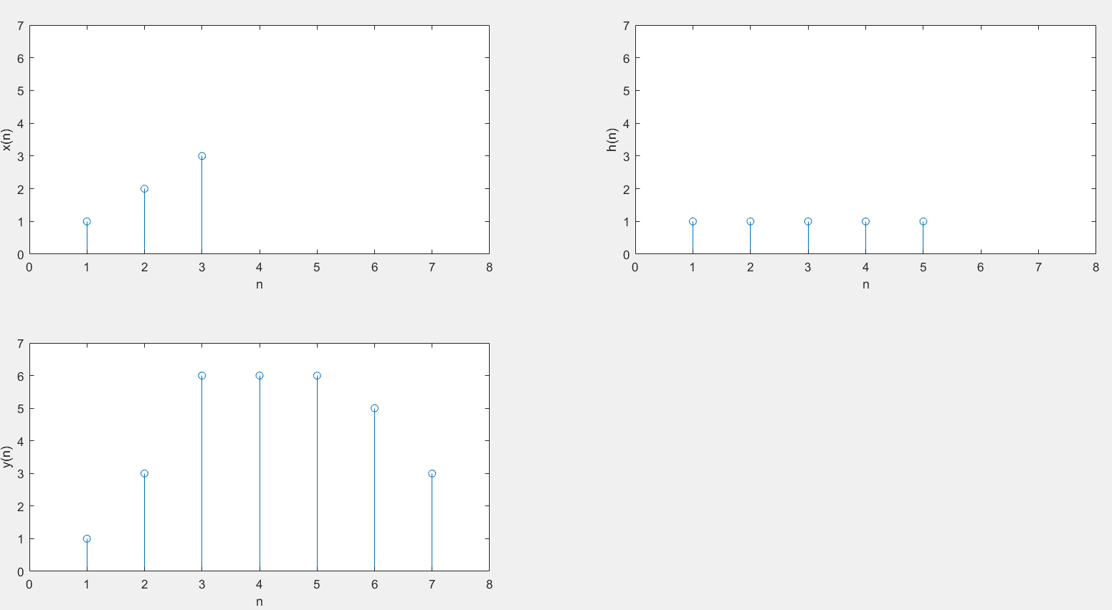

Figure 05: Variation of x(n), h(n) and y(n) with n

2) x(n) = { 1,2,3,4,5 }, h(n) = {1}

**Code**

clear all;

x=[1,2,3,4,5];

h=[1];

y=conv(x,h);

n1=1:length(x);

n2=1:length(h);

n3=1:length(y);

subplot(2,2,1);

stem(n1,x)

axis( [0 6 0 6]);

xlabel( 'n');

ylabel('x(n)');

subplot(2,2,2);

stem(n2,h)

axis( [0 6 0 6]);

xlabel( 'n');

ylabel('h(n)');

subplot(2,2,3);

stem(n3,y)

axis( [0 6 0 6]);

xlabel( 'n');

ylabel('y(n)');

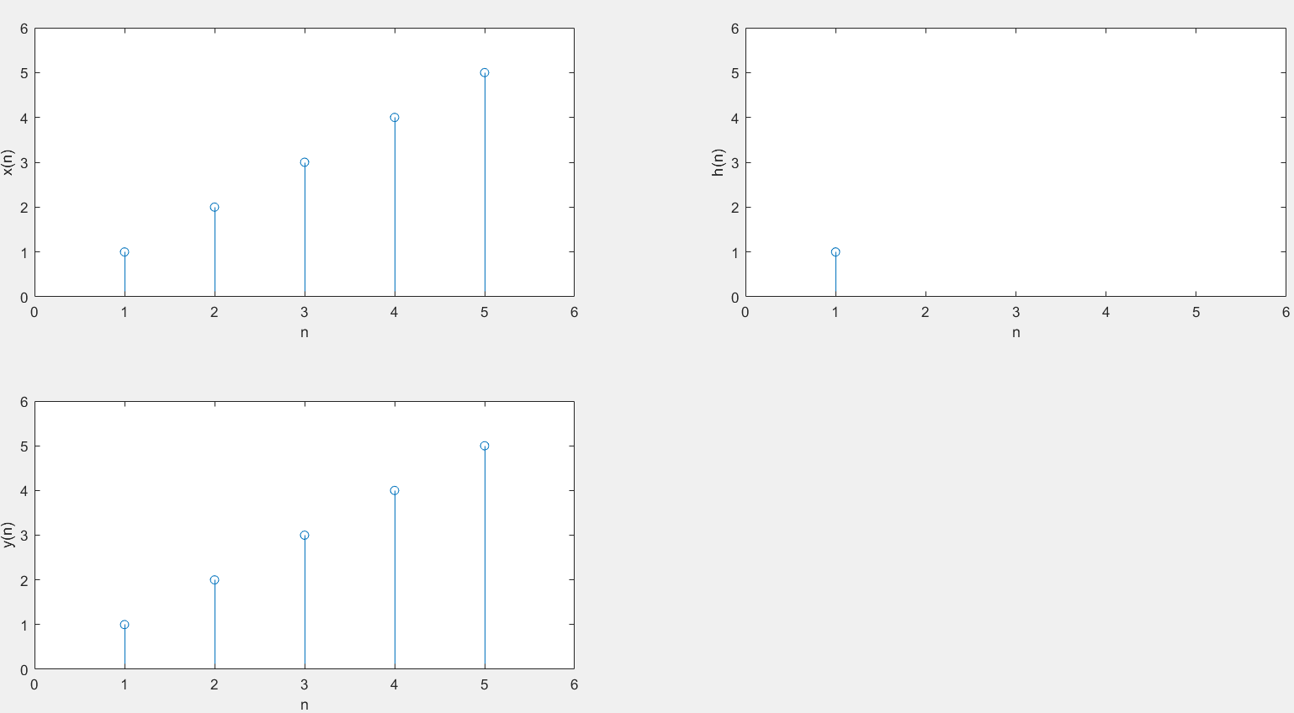

Figure 06: Variation of x(n), h(n) and y(n) with n

3) x(n) = h(n) ={ 1,2,0,2,1}

**Code**

clear all;

x=[1,2,0,2,1];

h=[1,2,0,2,1];

y=conv(x,h);

n1=1:length(x);

n2=1:length(h);

n3=1:length(y);

subplot(2,2,1);

stem(n1,x)

axis( [0 10 0 10]);

xlabel( 'n');

ylabel('x(n)');

subplot(2,2,2);

stem(n2,h)

axis( [0 10 0 10])

xlabel( 'n');

ylabel('h(n)');

subplot(2,2,3);

stem(n3,y)

axis([0 10 0 10])

xlabel( 'n');

ylabel('y(n)');

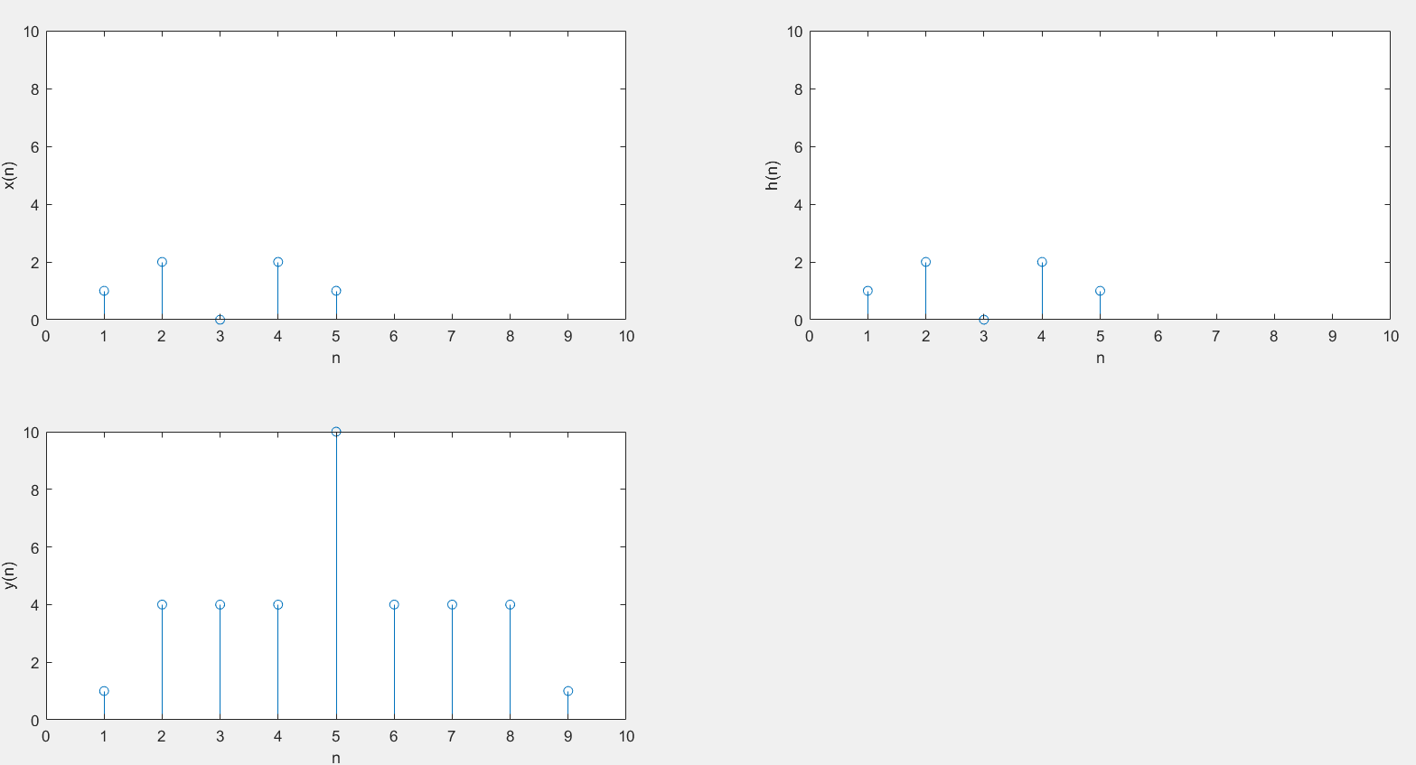Figure 06: Variation of x(n), h(n) and y(n) with n

Method 1 (Using MATLAB)

function r=h(n)

r=[];

count=1;

for i=n

if i>=0 && i<4

r(count)=0.5^i;

else

r(count)=0;

end

count = count+1;

end

By executing following program using above function,

clear all;

n=0:1:4;

h=h(n);

y=[1,2,2.5,3,3,3,2,1];

[x,r] = deconv(y,h);

disp(x);

Therefore, x(n) = 1.0000 , 1.5000 , 1.5000, 1.7500, 1.5625

Method 2 (Manual Calculation)

h(n) = 1, 1/2 , 1/4, 1/8

y(n) = 1, 2, 2.5, 3, 3, 3, 2, 1,0

Consider, x(n) = a, b, c, d, e

|  |  |  |  |  |
| --- | --- | --- | --- | --- |
|  | 1 | 1/2 | 1/4 | 1/8 |
| a | a | a/2 | a/4 | a/8 |
| b | b | b/2 | b/4 | b/8 |
| c | c | c/2 | c/4 | c/8 |
| d | d | d/2 | d/4 | d/8 |
| e | e | e/2 | e/4 | e/8 |

Equating diagonal sum with y values,

a = y(0)

a = 1

a/2 + b = 2

1/2 + b = 2

b = 1.5

a/4 + b/2 + c = 2.5

1/2 + 1.5/2 + c = 2.5

c = 1.5

a/8 + b/4 + c/2 + d = 3

1/8 + 1.5/4 + 1.5/2 + d = 3

d = 1.75

b/8 + c/4 + d/2 + e = 3

1.5/8 + 1.5/4 + 1.75/2 + e = 3

e = 1.5625

Therefore, x(n) ={ 1, 1.5, 1.5, 1.75, 1.5625 }

clear all;

n=0:1:4;

h=h(n);

y=[1,2,2.5,3,3,3,2,1,0];

[x,r] = deconv(y,h);

n1=1:length(x);

n2=1:length(h);

n3=1:length(y);

subplot(2,2,1);

stem(n1,x)

axis( [0 9 0 4]);

xlabel( 'n');

ylabel('x(n)');

subplot(2,2,2);

stem(n2,h)

axis( [0 9 0 4]);

xlabel( 'n');

ylabel('h(n)');

subplot(2,2,3);

stem(n3,y)

axis( [0 9 0 4]);

xlabel( 'n');

ylabel('y(n)');

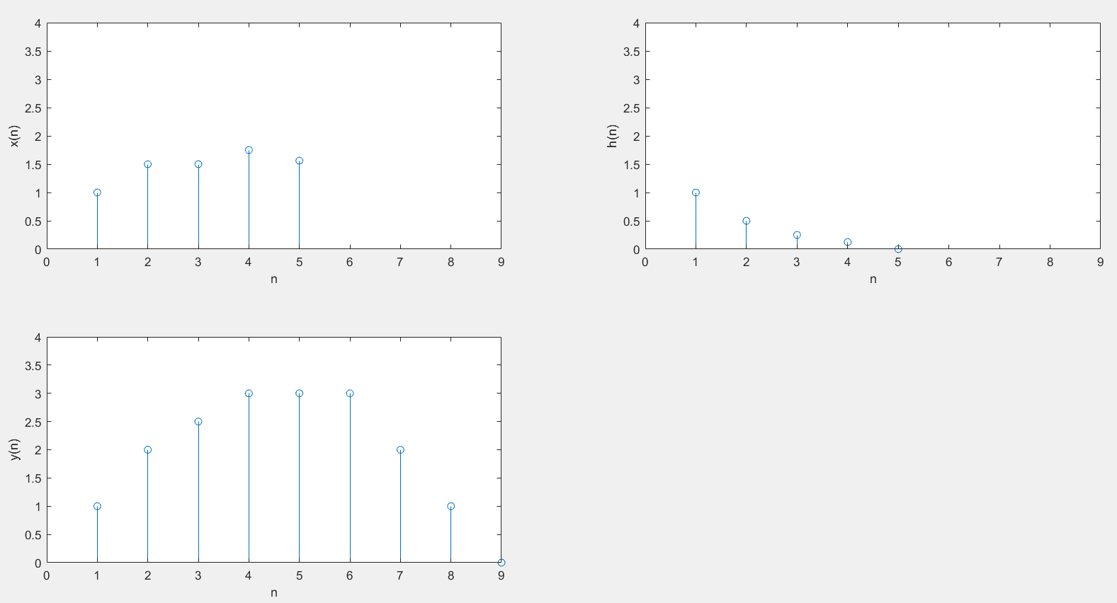

Figure 07: Variation of x(n), h(n) and y(n) with n